Non Ferrous Metals Recycling: Economic, Technical and
Environmental Aspects of Aluminium and Lead Market in Brazil

By Heloisa V. de Medina
email: hmedina@cetem.gov.br
Introduction
On recent years, pollution prevention, waste minimisation, materials recovery and end-of-life products recycling has been a growing subject of interest. Strictly speaking mineral industry, materials producers and materials based manufactures are at the core of these concerns. Worldwide new materials and new products were developed to be recycled. Furthermore designing activities were enlarged to cope with the principle of life-cycle product management. However according to life cycle principle recyclability does not assure sustainability. In terms of the sustainability of mineral and materials industry the recycling activities means maximisation of minerals utilisation (extending natural resources lifetime), minimisation of energy usage (enforcing energy conservation), minimisation of materials production (reducing costs and wastes). But on the other hand it also claims for protection of human health and ecology, clean technologies (at both levels: production and recycling), enforced environmental legislation, well-organised collection systems and large market assuring secondary materials supply and demand for recycled materials. Ability of Mineral and
On this sense recycling metals protecting the environment is an example of how difficult it can be. For instance clean recycling processes avoiding emissions and water contamination by heavy metals and other toxic elements is an ever-present challenge. Quoting Wernick and Themelis (1998) "The success of secondary metals markets depends on the cost of retrieving and processing metals embedded in abandoned structures, discarded products, and other waste streams, relative to the prices of primary metals."
The economic viability of recycling processes is also a key issue for the emerging recycling industries that are often linked to complex waste streams from civil construction, and end of life products (ELP). In the words of Wernick and Themelis (1998): "Demand for scrap metals depends on industry structure and the availability of production technologies that accommodate scrap feeds to yield value added products. This complex market relies on the decisions of many independent actors, including scrap dealers, brokers, dismantlers, and smelters."
For ELP the major contribution comes from automobile industry and electric and electronics products which are the largest materials intensive industrial sectors. Besides that the economic viability of recycling for such ELP depends on materials separation, the first stage in the metal recycling chain. Materials treatments, chemical and metallurgical processes as well as lower concentrations of the desired metal in the secondary source increase the difficulty of separation. On the other hand new technologies such as spectroscopic analysis using lasers introduced in shredding operations came to assure and to speed the technical evolution in this field. Anyway to get the best and the soundest methods on separation is nowadays the most important challenger for materials science and engineering. And this is specially true for metals and their alloys since they often are contaminated by chemical treatments and assembly processes such as joining techniques, painting etc. In short "Virtually all of the materials in today's automobile can technically be recycled the challenge facing engineers is making recycling process economical"(Coulter and al.1998). And we could add that they also have to search how to do it with no additional environmental impacts.
For automobile industry, according to European Automobile Manufacturers Association (ACEA) (http://www.acea.be) the factors that determine the recyclability of single materials and components include the purity of the recovered products, the market for the recovered products, the monetary value of the material, the cost of collection and transport, the cost of sorting, the cost of transformation into reusable material and the cost of disposing of any residual material.
This is exactly what DFR (Design for Recycling) practices are looking for: to provide an added value recycling condition to new products at the end of their life. DFR is a new concept of the design activity that incorporates materials recyclability from the very beginning of the product creation. So complex products like automobile has to be designed to be assembled and disassembled.
In fact, nowadays materials and products are being redefined and designed according to the consumers’ expectations, reaching to improve the engine performance as well as to rend new products technologically innovative and environmentally friendly.
In the last decade recyclability improvements has been motivated by many different reasons among then we can point out:
- more restrict environmental legislation
- unstable supply of natural resources particularly some rare metals
- reducing the developed countries dependence on strategic metals
- Economic advantages of secondary metals production: lower energy consumption, global emissions and production costs.
- emergence of new recycling technologies
- establishment of ELP collecting systems(aluminium can, automotive batteries, tires)
- designing for environment and designing for recycling practices
- development of new and recyclable materials and products
- economic opportunity in terms of income and jobs for the less developing countries

1. Non Ferrous metals Recycling in Brazil: an Overview
This text aims to present an overview of the main aspects of non-ferrous metals recycling market in Brazil illustrated by two examples: aluminium and lead. For these materials and their recovery and recycling processes we are going to discuss the technical and economic aspects that represent the strengths and the weakness for future development of recycling market. From medium and short term the perspective of the challenges as well as the opportunities will also be analysed. These materials were picked out for their importance on Brazilian market, in terms of income and employment, and for the challenges that they pose to the environmental management and industrial organisation. They represent two main axes:
- Market pulled materials such as aluminium that have impressive economic advantages and one of the greatest world markets in Brazil for can recycling.
- Materials that claim for new and clean technologies and sound recycling process management avoiding extra environmental impacts such as lead from car batteries.
According to the National Department of Mineral Production (DNPM Annual Summary 2002) " The product of mineral extractive industry including petroleum and natural gas was estimated at US$ 12.6 billion, corresponding to 2.5% of the GDP. However, when we consider the multiplier effect of the added value of the total output of industrial processes based on mineral raw materials the output of the mineral-based industries amounted to US$ 42.6 billion, and had a share of 8.4% in GDP." ... " In 2001, the country produced about 70 mineral commodities, split into metallic minerals group, 21, non-metallic, 45 and energy, 4." The chart above provides an overview of the importance of mineral production on Brazilian Economy (extracted from Mineral Summary 2002 electronic version available at the site http://www.dnpm.gov.br).

INFLUENCE OF MINERAL GOODS IN THE

DOMESTIC ECONOMY
(2001)

EXTRACTIVE MINERAL INDUSTRY PRODUCT

US$ 12.6 billion
MANUFACTURE MINERAL INDUSTRY
PRODUCT: metals, cement, chemicals, fertilizers, etc.

US$ 42.6 billion
GROSS DOMESTIC PRODUCT - GDP

US$ 503.9 billion ion

Manufacturing
Industry
Extractive
BRAZILIAN MINERAL RESOURCES
Industry
Iron and steel metallurgy,
refine, etc.
Mines,
'garimpos',
quarries, etc.

DOMESTIC RECYCLING OF SCRAP: aluminum, lead, copper,
zinc, tin, etc.

IMPORTS OF
PRIMARY MINERAL GOODS:
Petroleum, coal, sulfur, etc.

US$ 1.7 billion
IMPORTS OF CHEMICAL, SEMI- AND MANUFACTURED
PRODUCTS: alloys- and steel, copper, aluminum, fertilizers, etc.

US$ 3.6 billion
EXPORTS OF PRIMARY, CHEMICAL, SEMI- AND
MANUFACTURED: iron, manganese, steel and alloys; etc.

US$ 9.9 billion

FOREIGN MINERAL Resource's

In terms of exports of manufactured goods aluminium is at the third place only just after Iron and Petrol. For lead we have no primary extraction since 1996 and nevertheless we have had one of the biggest domestic's apparent consumption increase in the last two years. The evolution of national mineral production for Aluminium, Copper, Lead and Zinc and the Apparent Consumption of Metallic Lead Products are presented at Table 1 and Table 2.

Table 1: Recent Evolution of Brazilian Mineral Production of Aluminium, Copper, Lead and Zinc
Minerals | Specifications | 1995 | 1998 | 2001
Aluminium | Primary Metal | 1 188 000 | 1 208 000 | 1 140 000
Aluminium | Recycled Metal | 92 000 | 170 000 | 200 000
Copper | Primary Metal | 164 966 | 167 205 | 212 243
Copper | Secondary Metal | 54 400 | 54 150 | 36 000
Lead | Primary Metal | 13 958 | - | -
Lead | Secondary Metal | 50 000 | 48 000 | 52 000
Zinc | Primary Metal | 188 033 | 176 806 | 193 061
Zinc | Secondary Metal | 7200 | N.D. | N.D.
Sources: DNPM, Mineral Summary 1996, 2000, 2002 Notes: (-) Null (N.D.) Not determined

Table 2: Apparent Consumption of Metallic Lead Products in Brazil (1997-2001)
 | 1997 | 1998 | 1999 | 2000 | 2001
Production of secondary lead | 53 | 48 | 52 | 52 | 52
Import | 60,7 | 60 | 56 | 70,7 | 73,4
Consumption | 113,7 | 108 | 108 | 122,7 | 125,4
Source: Trouche V. 2003(the consumption was estimate by the author based on DNPM data)

2. Aluminium Recycling in Brazil
Brazil is the first one in aluminium can recycling and the sixth largest primary Aluminium producer in the world after United States, Russia, China, Canada and Australia. Aluminium industry in Brazil employed around 50.000 people in the year 2001, and generated an annual income of US$ 5.7 billions, which represented 1,2 % of the GDP and 3,4% of GDP Industrial participation. Aluminium Recycling Market has an important social role because it generates more than 150 000 non-specialised jobs in collection of Aluminium cans.
According to ABAL "Brazil recycled 87% of all the aluminium cans consumed in 2002. This rate, which was calculated by the ABAL (Associação Brasileira do Alumínio - Brazilian Aluminium Association), maintains the country as the world champion in aluminium can recycling, among the countries in which recycling is not mandatory by law. (...) Among the benefits generated by aluminium can recycling, the highlights are environmental preservation – in addition to reducing the extraction of bauxite, recycling liberates room in sanitary landfills –, and savings in electric power, which reaches as much as 95% in the production process."..." Still focusing on electric power, aluminium can recycling in Brazil, during 2002, generated savings of close 1,700 GWh/year, which corresponds to roughly 0,5% of all the energy produced in the country."(http://www.abal.org.br).

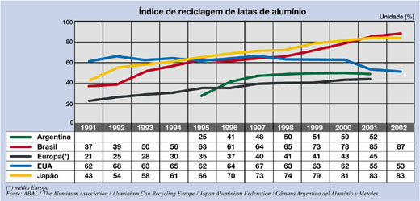
In the standpoint of SWOT's analysis (Strengths, Weakness, Opportunities and Threats) we identified the follow factors as the aluminium recycling strengths: energy saving, cost effectiveness. Additionally the existence of large markets (for both supply and consumption sides), a well-organised collection system and a good level of R&D partnerships in product and process development are also economic, social and infra-structure advantages.
On the other hand, the main aluminium recycling weakness are: the great number of aluminium alloys for industrial uses and the high level of chemical contamination of the aluminium scrap from end of life products such as lacquers, plastic coatings, paints etc. Besides that the aluminium for automobile uses, for instance, has introduced dozen of new alloys and composites materials that must be separate to prevent downgrading of the secondary aluminium products.
In the case of aluminium we found no threats since we have been improving our market share continuously for more than ten years. And we can also say that for Brazil the best opportunities are quite liked to the technological challenges, which we have been reaching in terms of environmental sound management and clean technologies developments. The best example of that is the success story of IPT's new patent of a no emission furnace by plasma instead of traditional oxidising process largely utilised by Alcan. (www.ipt.br/inovação/exemplos/aluminio/riqueza).
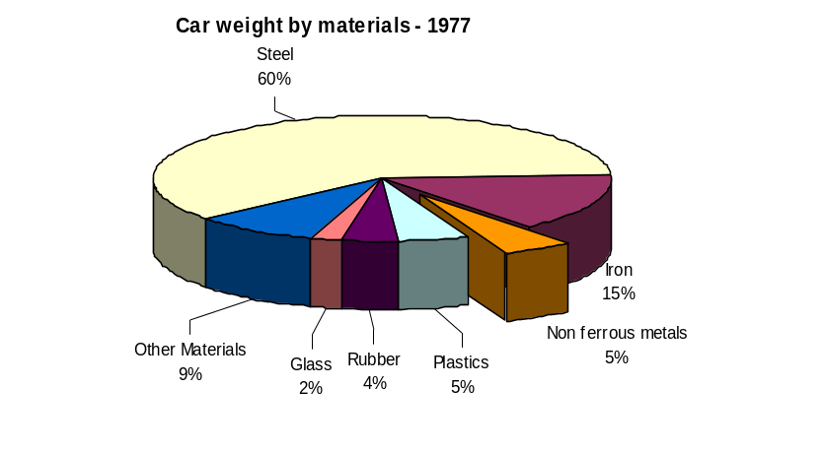In Brazil aluminium and its alloys has also growing application on automobile industry. The average rate of aluminium on a North American car weight is around 118 kg and according to ABAL (Brazilian Association of Aluminium) this rate in Brazil is 45 Kg.
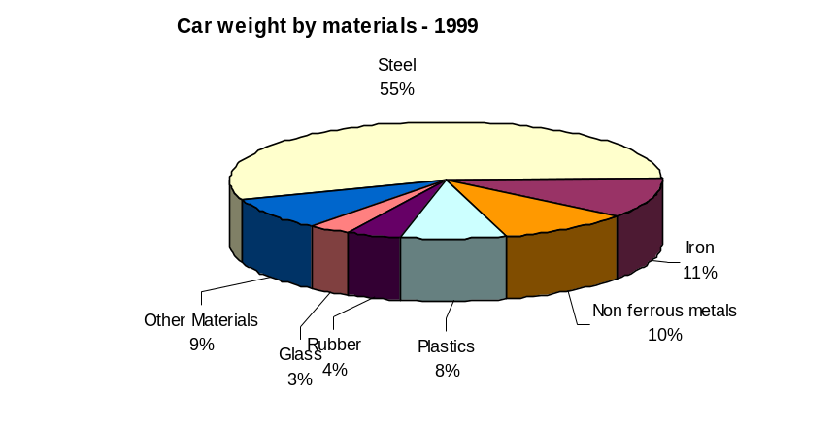As we can see the composition of a typical car has changed substantially in recent years. Steel, for example, has declined significantly, as lighter materials such as non- ferrous metals, polymers, and other more fuel-efficient materials are being incorporated into new vehicle design.
Gerard Maeder Chief of Materials Engineering at Renault talks about these changes to the Magazine of R&D Renault April 2003 (the Dossier The New World of Materials)
- “ In the auto industry the future of materials is linked to product development and its main issues, which are: safety, environment and reliability/durability. ...In terms of environment, one of our main levers is that of shedding weight, with increasing recourse to low-density materials such as Al, magnesium and fiber-reinforced polymers (currently glass fiber and tomorrow carbon fibers). He said that is also important to improve materials resistance to environmental stress and for corrosion it means zinc galvanisation.

- Lead Recycling from Lead-Acid Batteries
The importance of lead recycling is strictly linked to the environmental requirements in both senses claiming for cleaner recycling processes and for technological innovation, such as rechargeable batteries, long lasting batteries for electric or hybrid vehicles. In short it demands new technological trails leading too much more efficient batteries. In between nickel, zinc oxide, titanium nitride, and lithium are in perspective for future developments for vehicle uses. In this context the design of new batteries and the materials selection are suppose to have a great impact on recycling process in medium-term and even short-term.
Nowadays scrap automotive batteries (lead-acid batteries) are the major source of secondary lead in Brazil as all over the world. And the main environmental issues concerning ULAB (usage lead acid batteries) are the risk of water, soil and air contamination. ULABs are a hazardous waste for recycling proposes as well as final disposal. Additionally to lead, automotive batteries have also acids and other metals and minerals such as arsenic, antimony, tin, calcium - in suspension and solution. But the lead (oxide and metallic) represents around 70% in car batteries' weight.
Car batteries are recycled all over the world at different rates such at 90 % in European Union and at 50 % in less developed countries. In Brazil we do not have official data or systematic studies on batteries recycling but a engineering student of INSA de Lyon Vincent Trouche made a 5 months case study under my supervision (from April to August 2003) and he estimated this rate on an interval from 65 to 80 %.

The Recycling Loop of Vehicles Batteries in Brazil
Battery Production

24000 Pb
End-User
65000 Pb
Collection Network

80%
20%
Recycling Plant

33000 Pb

< 100 Pb
Export Batteries
Import Pb metal 47000 Pb
Lost Batteries
Lost Acid
Slag. Effluents

Source: Trouche V. (2003)

Besides that a recent study conducted by researchers at the Chemical Institute of UFRJ (Federal University of Rio de Janeiro) and at the FIOCRUZ (Oswaldo Cruz Foundation) provided indicators of environmental pollution in areas adjacent to a source of stationary lead emission based on dust and air contamination. This study measured lead concentration in both the outdoor air and the household dust from houses located around a lead-acid battery repair shop. As a result over 50% of the air samples exceeded the standard limit (1.5 ug Pb.m⁻³) (for more details see http://www.scielo.br)

Concerning technical aspects pyrometallurgical refining (on blast furnace and rotary furnace) is traditionally the most used process worldwide for both primary and secondary lead productions. Monitoring and preventing the escape of dust and fume is crucial. Hydrometallurgical methods are the newest and the soundest technology developed but its economic and industrial viability has to be proved. Hydrometallurgy is a chemical metal processing technology to dissolve a metal from its concentrate by using water, oxygen and other substances on a pressurised vessel. Compared to the pyrometallurgy process it is more environmentally friendly and uses much less energy. On the other hand its industrial scale is over 10 times smaller than the conventional pyrometallurgical smelters plants.
The first steps on this via was made by US Bureau of Mines by the end of the 70's and the first results were published in 1981. At industrial level the best initiatives were provided by Engitec Technologies in 1992 (CX-EW and CX Compact). The CX plants in operation are considered as state of art units for environmentally friendly design, for the quality of the recovered products and for the quality of design and manufacture of the equipment. (See in details http://www.engitec.com or email info@engitec.com).
In Brazil, CETEM carried out a 5 five year research on recycling domestic batteries and automotive batteries. The aim of the first project was to determine the level of contamination of final disposal of domestic batteries on proper conditions. The second one aimed to reduce the environmental impacts of the pyrometallurgical process by associating a hydrometallurgical phase for lead paste desulphurisation from car batteries.
These research at CETEM were encourage by CONAMA's Resolutions on batteries final disposal and recycling, by the end of the ninths (228/97, 235/98, 257/99) inspired on the 1994 Basel Convention the ban of exports of hazardous waste (including ULAB) from developed to developing countries.
In 1989, Basel Convention was first conceived to control the movements of hazardous waste and their final disposal and became part of the Brazilian Environmental Regulations on July 1993.
On April 2001 a Draft Technical Guidelines on the Environmentally sound management of Lead-Acid Battery waste was presented at the eighteenth session of the Technical Working Group. This Draft stands a board view of batteries recycling process from storing, collecting and transporting named pre-recycling phase. "Before reaching the recycle plant, used batteries must be collected, transported and stored with proper care, in order to avoid health and environmental contamination Since these procedures are not performed inside the recycling facility, they are denominated pre-recycling on this document". After this the recycling process itself are considered in this paper as ideally divided in three major processes: Battery opening (draining); lead reduction and lead refining. Specific recommendations on air, water and soil pollution prevention and effluent treatment are also provided. Two photos, that we got from one of the greatest Tires and Batteries Collection and Transportation Company - Mazola Pneus -, show how Brazil is transporting and packing ULAB. (see at http://mazolapneus.com.br)
The more restrict environmental regulations and the continuous falling down of international metallic lead prices through the lead recycling sector in Brazil into the ever present crisis.

After 1995 most of lead recycler companies were shut down (a dozen of them in Rio de Janeiro) and the ones that remains are operating at a very low production scale. Some of them were shut down after 1995 by Environmental Federal Authorities under the pressure of the NGOs. Other were close down for financial and economic reasons such as over capacity and lack of suppliers such as Cobrac a primary lead producer, shut down in 1995 due to the depletion of mineral reserves. Among the most important ones we can mention: FAE and independent one that had 2 industrial plants (São Paulo and Rio Grande do Sul) with an annual capacity of 24.000 tons, and Saturnia - Microlite a vertically integrated Co with a capacity of 18000 tons per year.

The Geographic Distribution of the Brazilian Recyclers
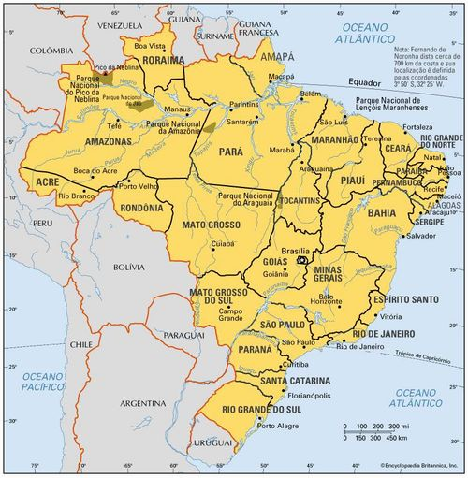
20.000
12.000
12.000
10.000
Extracted from Trouche V. 2003

- Tonolli for instance is an independent recycler in São Paulo State with a capacity of 36.000 t. /year but actually produced around 12.000 in the year of 2001.
- Moura is an integrated company (batteries and lead recycle) is located in Pernambuco State Northeast of Brazil, with a capacity of 22.000 t. per year
- Tamara Metais is an independent company for metals recycle located at The State of Parana producing 12.000 tons per year.
- Sulina de Metais located at the State of Rio Grande do Sul with annual production of 11.000 tons.
Nowadays the Brazilian Lead Recycling Market is passing through a risk situation in both senses economic and environmental. There are a number of informal lead smelters and even some big companies, which are operating under risky situations. Recent Greenpeace investigations, for example, revealed that Moura, one of the largest manufactures of car batteries in Brazil, is still importing ULAB.
For automotive batteries the national scenario also includes some important threats concerning the sound management practices requirements for recycling activities in Brazil such as:
- The lack of a National Programme for collection vehicles batteries, as we have for the aluminium cans.
- The large number of irregular final disposals at 90% of the Brazilian municipalities, mainly at the Northeast, North and Central regions.
- The environmental legislation is not enforced by an effective system at local level;
- The out-dated recycling technology based on pyrometallurgy processes
In a short run perspective the over capacity of Brazilian Batteries Producers and Recyclers associated at the depletion of the mineral reserves can be taken as opportunities to a enhancing the development of lead recycling sector.
From a medium or long-term perspective the following factors can be considered as the main challenges to a national policy for a sound recycling management:
- to improve the collection system organisation at local and national level
- To minimise waste transportation since it represents a high cost due to Brazilian geographic dimension
- To promote materials, product and process development towards cleaner recycling technologies
- To extend the polluter-pays principal to product manufactures concerning end of life products responsibility
- To encourage the design for environment and the design for recycling practices

- Final Remarks
In this scenario recycling is surely a great opportunity for the less developed countries’ to get into the Research, Development and Designing of materials and manufactured products, which up to now concerned only the headquarters bureau employees. That is also a means of get from all actors their commitment and contribution to the sustainability of mining and materials industry and of automobile and other manufactured products. Working in network as partners they can share risks and profits and also get more innovative solutions to improve the recyclability of ELP on technical, economic and environmental bases.

Bibliography:
Araujo R. V. V., Soares P. S. M., Trindade R.E. "Estudo da desulfurisacão da pasta de bateria automotiva visando a reciclagem de chumbo." Rélatorio Tecnico 58, Centro de Technologia Mineral, 2001.
Andrews D., Raychaudhuri A., Frias C., "Environmentally sound technologies for recycling secondary lead", Journal of Power Sources 88, 2000, 124-129.
Bellmann K., and Khare A., 2000, "Economic issues in recycling end-of-life vehicles", Technovation, vol 20, pp.677-690.
Coulter S., Bras B., Winslow G. and Yester S., 1998, "Designing for Materials Separation: Lessons form Automotive Recycling", Journal of Mechanical Design, September, vol.120, pp. 501-509, copyright by Transactions of the ASME.
DNPM - Departamento Nacional de Produção Mineral do Brasil- 2002, Mineral Summary, (http://www.dnpm.gov.br (publicações English version).
Hakada K. and Yamamoto R., 2001, "The Current Status of Research and Development on Ecomaterials around the World", MRS Bulletin, November, pp. 871-879.
Marchetto I., "A reciclagem do chumbo no Brasil", Seminário de Reciclagem de Metais Não-Ferrosos, ABM Associação Brasileira de Metalurgia, October 2000 – São Paulo.
Medina H. V. de et Sédilleau P. 2001 "L'Industrie Automobile se Réorganise pour le Recyclage", article présenté au IX International GERPISA le 06 Juin, à Paris, et publié dans les Actes du GERPISA.
Medina H. V. de, 2002, "The sustainability of the Automobile for the 21st Century", Lettre du GERPISA Nº 162, sept. /Oct. Paris, França
Quitério S. L., Silva C.R. S. da, Vaitsman D. S., et al. 2001, "Use of dust and air as indicators of environmental pollution in areas adjacent to a source of stationary lead emission", Cadernos de Saúde Pública, FIOCRUZ, Rio de Janeiro, Brasil, e-version available at http://www.scielo.br.
Ribeiro J. A. S., 2001, "Cobre" em Balanço Mineral Brasileiro, e-version available at: http://www.dnpm.gov.br.
Sato C.H., Araújo R.V.V. de, Trindade R.B.E., "Estudo da Dessulfurização da pasta de Baterias Automotivas visando a recuperação de chumbo." Jornada de Iniciação Científica do CETEM, 2002.
Stone H., Effects of Amendments to the Basel Convention on battery recycling", journal of Power Sources, 78, 1999, 215-255.
Trouche V. 2003, "Le recyclage de Batterie Automobile au Brésil" monographie: Projet de Fin d'Etudes en Génie Productique au L'INSA de Lyon, France., réalisé au CETEM, Brésil, sous la direction de Heloisa V. de MEDINA, 82 p.
Valdez H., "Lead battery markets and recycling in Mexico and South America" JOM V.67 (1997)
Villas Bôas R. C. (editor) 1995, Sustainable Development and the Advanced Materials: The Brazilian Case, CETEM Brazil and IDRC Canada., copyright by CETEM/CNPq Rio de Janeiro p. 290.
Wernick I. and Themelis N. J., 1998, " Recycling Metals for the Environment", Annual Review Energy and Environment, vol 23, pp 465-497, copyright by Annual Reviews (http://www.AnnualReviews.org).
Technical Reports
UNCTAD -United Nations Conference on Trade and Development- A review of the options for restructuring the secondary lead acid battery industry, in particular the smaller battery recyclers and secondary lead smelter and the informal sector, with a view to enhancing their environmental performance and improving health standards. UNCTAD 08/1998.
IPPC -European Union Integrated Pollution Prevention and Control - Integrated Pollution Prevention and Control. Reference document on Best Available Techniques in the non-ferrous metal industries. EU December 2001.
Basel Convention Technical Working Group, Draft Guidelines on the Environmentally Sound Management of Lead-acid Battery Waste, report elaborated for the Basel Convention Secretariat. April 2001.

Internet Sites:
Abal : http://www.abal.org.br/numeros/index.ctm?frame=numeros_recyclagem, "Indice de reciclagem de latas de alumínio".(English version available)
ENGITEC Technologies : http://www.engitec.com
Greenpeace : http://www.greenpeace.org
INFOMET : http://www.infomet.com.br
Setor Reciclagem : http://www.setorreciclagem.com.br/noticias/ambbra06.html "Reciclagem já economiza 95% de energia na produção de latas de alumínio".

